Class 7: Towards a Pursuit of Identity
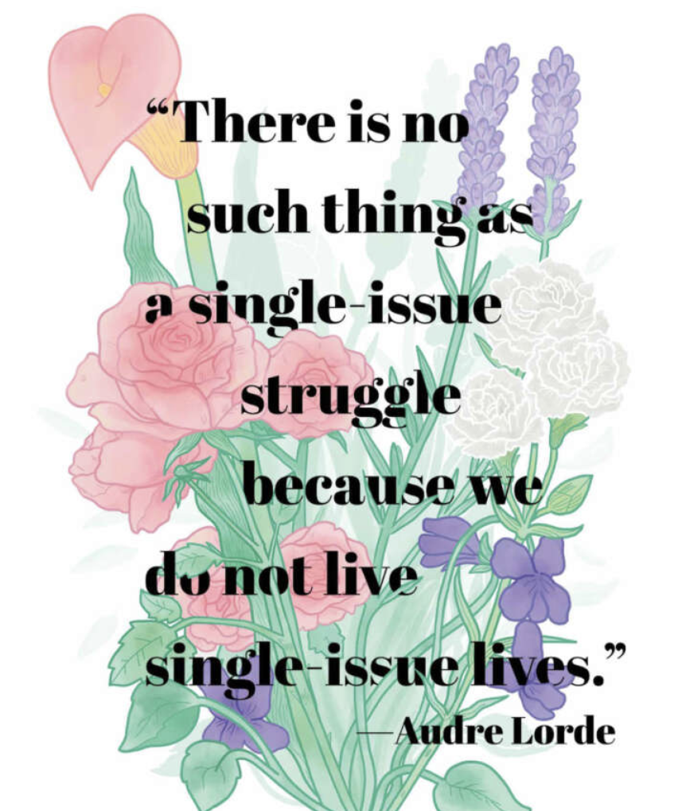

498 Non-Negotiables: Our Collective Agreement for Online Etiquette
For detailed description of each agreements click here
- Remember that everyone has been through their own challenges, and that emotion/passion is not the same as weakness/irrationality. Be considerate of others and understand that they are trying to engage with you and your culture, so you should respectfully attempt to do the same. *Staying committed to shared understanding
- Engage constructively with others online as you would with people in person; with respect, kindness, and empathy.
- Use technology meaningfully and responsibly, ensuring that you are aware of the strengths and limitations of your digital resources.
- Value the other person's contributions online by considering time and be as respectful as you would in real life interactions.
- Ensure your face is in full frame and that you do not have any distracting backgrounds or visual effects enabled. Be present to the fullest extent possible, as though you were in an in-person setting.
- Make contributions with informed foundations from depth of practice and research and participate with critical thinking. It’s okay to be unfamiliar with a topic; that’s the point of learning, continue leverage cultural resources in the community
- Accept that disagreements and discomfort will occur, and advocate for open and respectful communication. Experiencing discomfort and conflict helps us to grow as learners.
- Respect other people's privacy and do not share personal information that others shared during the class. Focus on the lesson, not the story
- Be mindful of your own privilege and power; do not weaponize it but use it to uplift others by listening, respecting differences of opinion (as they TOO can be right) and make space for everyone to contribute.
- Approach the mistakes, yours and your peers, with empathy and openness; to be human is to make mistakes. Recognize in these moments opportunities for growth, deeper understanding of ourselves, our community and the topics we are tackling.

Wellness Check-in: Grateful Threads
Reflect on one aspect of your identity that they feel grateful for today. This can include cultural heritage, personality traits, or community connections.
Share a couple of words why you’re grateful for this part of yourself
For example: “I’m grateful for my multilingualism because it connects me to my family, community and multiple ways of knowing; it helps me advocate for others which brings me a lot of joy”

A few notes from our mid-semester check-in:
- No fully asynchronous class for the rest of the semester
- More balance with the asynchronous class time ( closer to an even split)
- More intentional time to process first (freewriting) and share out in small/ whole group discussions second

Slides

Activity 1: Layers of Me: Unearthing Identity (10 min)
Summer 2026 Layers of Me: Unearthing Identity

Break: 6:00-6:10

Activity 2: Weaving Perspectives – A Layered Strand Discussion
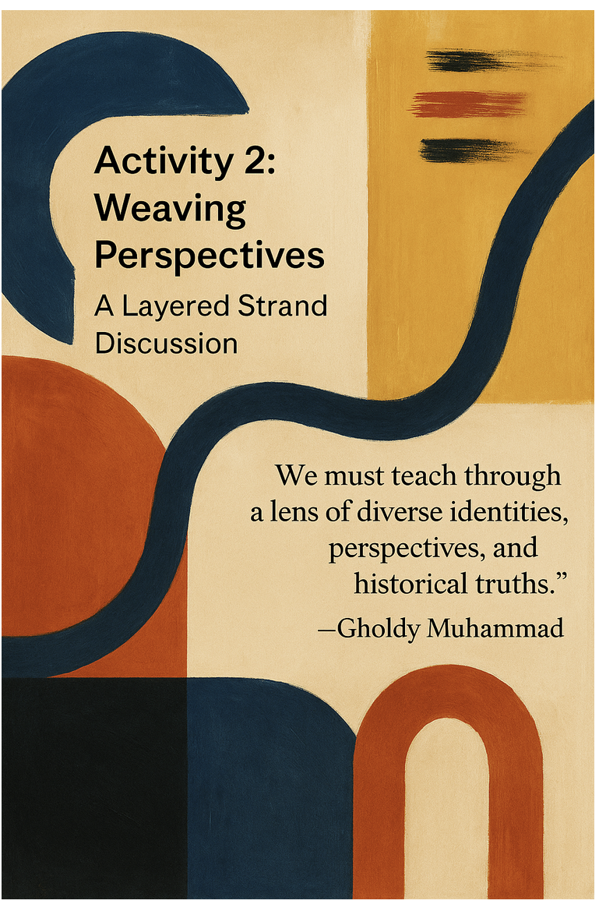

We will share a personal insight from our choice board reading (or an alternative text if preferred). This will include a brief multimodal storytelling summary of the reading, grounded in your own cultural perspective, and a connection to your identity. You may choose any format for your presentation.
Multimodal storytelling refers to communicating meaning through a combination of modes such as text, images, audio, video, gesture, and/or movement.
This activity is designed to create space for all voices and ways of knowing.
Directions:
- 5 minutes: Individual freewrite
- 5 minutes: 1:1 breakout room discussion to decide what you will share
- 15 minutes: Independent preparation
- Share-out (2–3 minutes each): Share only what you feel comfortable sharing, while helping maintain a respectful space where all participants feel included and not othered or judged

Share Reflections Here. Can be a link to a document, a visual, text, etc.

Asynchronous Work

Layered Genius: Designing for Joy and Identity

Step 1: Define Your Focus
Identify:
- Grade level
- Discipline
- Potential focus for your mini-unit
Step 2: Initial Lesson Plan
If needed, review past cohort examples for inspiration. ​​Mini Unit Some examples are not final products
Begin by drafting one lesson plan that connects students to their intersecting identities and explicitly engages only the two of the five pursuits we have already covered:
- Joy
- Identity
- Skills
- Intellect
- Criticality
Over the coming weeks, you will expand this lesson to incorporate all five pursuits more explicitly.
Use the provided template below. If you choose to work in a separate document, include a working link in the shared document. Feedback will be provided before the next class.

Step 3: Research Phase
- Review the student options below (choose one of the four provided students, or design your own if you currently work with students).
- If you create your own, ensure you include comparable identity markers and contextual details.
- If you are unfamiliar with aspects of your student’s identity, use this time to research cultural, linguistic, and/or community contexts that may shape their experiences.

Step 4: Lesson Plan Components
Joy
Explore whether and how the joyful literacy practices you identified in week 3 can be meaningfully integrated.
Identity
Design at least one element of the lesson that allows students to see themselves reflected in the content.
Skills (brainstorm notes only)
Identify key academic or disciplinary skills the lesson will develop.
Intellect (brainstorm notes only)
Outline the new knowledge or conceptual understanding students will build.
Criticality (brainstorm notes only)
Develop prompts that encourage students to question, analyze, or reflect on social issues.

Step 5: Multimodal & Multiliteracies
Ensure the lesson incorporates multimodal approaches (e.g., text, image, audio, video, gesture, movement). Consider:
- How does this instruction support multiple forms of literacy and expression?
- How does it help students learn about themselves and/or others?

Step 6: Inspiration
Refer to Muhammad (pp. 71–77) for lesson ideas and the example on p. 80 as a model.

Student #1: Amara (Social Studies)

- Background: Amara is a bilingual student whose family immigrated from Haiti when she was young. She is fluent in Haitian Creole and English and is currently learning Spanish. She loves storytelling, particularly when it connects her to her cultural heritage, and enjoys using art to express herself.
- Interests: Amara has a strong interest in history, particularly Black history and Haitian independence. She’s passionate about social justice and learning about influential leaders in African and Caribbean history.
- Identity Markers: Bilingual, immigrant, Caribbean heritage, social justice advocate, artistic, Queer..

Brainstorm Area
Identity
Joy
Skills
Intellect
Criticality

Student #2: Sofia (Science/Math)

Background: Sofia is a Mexican American student who excels in both math and science. She is very curious about how things work and often questions the environmental impact of different technologies. Sofia is also bilingual in English and Spanish and is involved in her local community garden.
- Interests: She loves hands-on activities, especially those that allow her to experiment with engineering and environmental science concepts. Sofia is particularly interested in renewable energy and how she can help her community through sustainable practices.
- Identity Markers: Bilingual, Mexican American, environmentalist, community-oriented, curious learner, has ADHD and recently diagnosed with autism.

Brainstorm
Identity
Joy
Skills
Intellect
Criticality

Student #3: Arjun (TESOL)
- Background: Arjun is a student who recently moved to the U.S. from India. He’s currently learning English and is highly motivated to succeed in his TESOL classes. Arjun is very interested in technology and enjoys spending time coding and creating digital artwork.
- Interests: Arjun is fascinated by global cultures and often seeks out content that connects him to his Indian heritage, such as Bollywood films and traditional music. He’s interested in using technology to bridge cultural gaps and has expressed a desire to learn more about app development.
- Identity Markers: English language learner, recent immigrant, technology enthusiast, culturally connected, artistic.

Brainstorm

Identity
Joy
Skills
Intellect
Criticality

Student 4: Malik (ELA)
- Background: Malik is an African American student who enjoys reading and analyzing contemporary literature, particularly stories that explore themes of identity and social justice. He is an avid writer and frequently shares his poetry online. He’s interested in exploring his identity through his writing and enjoys discussing cultural issues.
- Interests: Malik is passionate about spoken word and often writes pieces that reflect on his personal experiences as well as broader social issues. He’s involved in his school’s debate team and has a strong interest in public speaking.
- Identity Markers: African American, poet, social justice-oriented, reflective, verbally expressive, muslim, bilingual AAVE

Brainstorm
Identity
Skills
Intellect
Criticality

Student 5: Ethan (Computer Science)
Background: Ethan comes from a Seneca family and is proud of his Haudenosaunee heritage. While he is 25% white he often feels he is unsure how to represent both parts of himself. He enjoys computer science, coding, and problem-solving. He spends much of his free time building simple games, experimenting with programming languages, and exploring how technology can be used to address real-world challenges. He is particularly interested in how digital tools can support community engagement, storytelling, and the preservation of cultural knowledge.
Interests: Ethan is passionate about coding, robotics, and game design. He participates in his school's technology club and enjoys collaborating with peers on programming projects. Outside of school, he likes creating websites, learning new programming languages, and exploring emerging technologies such as artificial intelligence. He also enjoys spending time outdoors and learning about the history, traditions, and contemporary life of the Seneca Nation.
Identity Markers: Indigenous (Seneca), aspiring computer scientist, technology-oriented, analytical, collaborative, community-minded, culturally connected, creative problem-solver.
Brainstorm Area
Identity
Joy
Skills
Intellect
Criticality

Student :
Brainstorm Area
Identity
Joy
Skills
Intellect
Criticality

Student :
Brainstorm Area
Identity
Joy
Skills
Intellect
Criticality

Student :
Brainstorm Area
Identity
Joy
Skills
Intellect
Criticality

Student :
Brainstorm Area
Identity
Joy
Skills
Intellect
Criticality

Student :
Brainstorm Area
Identity
Joy
Skills
Intellect
Criticality

